Huntley CofE Primary School
Forest School Handbook
September 2024

“When we are at Huntley Forest School we will have time to play.
Our leaders will help us to create a space in which nature thrives and so do we”.

If you are volunteering, please ensure that you have signed in at the school office and wear your lanyard.

This is our vision for the children.
When we are at Huntley Forest School we will have time to play. Our leaders will help us to create a space in which nature thrives and so do we.
We will develop our school values of respect, perseverance and courage:
- We will respect our Forest School community – our classmates, our leaders, and all the wildlife we share it with.
- We will persevere as we try new things and follow our own ideas, sometimes in challenging environments.
- We will believe in ourselves and be courageous when we take risks; in the activities we do and in working with our friends.
We will follow the rules to make sure that we all stay safe.

You can help make this happen by:
- Being a facilitator for child-led learning – follow the children’s lead and support them in their explorations.
- Play – it doesn’t matter if things don’t work, or there doesn’t seem a point to it, go with it and see where you end up.
- Manage risks, but don’t eliminate them.
- Engage with and enjoy the nature.

Before joining a session, all staff and volunteers must familiarise themselves with the Forest School Handbook for Helpers (this document), including the relevant school policies on safeguarding and confidentiality, and sign the form to say that you have done so.

If necessary, please also inform the Forest School leader about:
- Any allergies or dietary requirements that you may have
- Your emergency contact details (if we don’t have them in the school office).

What is Forest School?

Forest School is an inspirational, child-led learning process that provides opportunities for learners to explore hands-on experiences in a natural setting. Multi-level development takes place when learners apply learnt experiences and build self regulation.
It’s roots lie in Scandinavian culture where, from an early age, ‘friluftslive’ (free air life), ie. exposure to the elements, fire and risk is simply the way of life.
Forest School is resoundingly not the same as outdoor learning. Yes, learning takes place, of course it does. But the principles of Forest School combine to create something far greater than a lesson that takes place in a different environment where the community and child-led learning enable truly holistic development.

The full value of Forest School is experienced when it’s 6 guiding principles are successfully combined:

REGULAR SESSIONS
Forest School is a long-term process. Regular sessions (ideally weekly, over 2 seasons) enable the participants to develop their skills, manage ongoing projects and observe the changes in their environment.
This structure allows for observations and a progression of learning (scaffolding) and for collaboration and trust to develop. Future sessions are planned based on the developing behavioral and physical capabilities of the participants.

IN A NATURAL SETTING
Often in a woodland, but it could be a beach or any natural setting with space to explore and discover. The outdoor space allows the development of a personal, positive, lifelong relationship between the learner and the natural world, and an understanding of their place within it and a sustainable future. Away from the traditional classroom, the natural setting creates a sense of calm and well-being.
Over the course of the sessions, the changing environment provides subtle ever-changing moods, natural challenges and new sights and smells that fill each visit to Forest School with unique potential to inspire curious minds. Natural resources inspire, stimulate and motivate ideas.

A COMMUNITY OF CHILD-LED LEARNING
The needs of the learner are the driving force, inspiring an uptake of knowledge.
Leaders observe and are responsive to their learners needs and interests. They reflect on sessions, with the learners, to understand their achievements, develop emotional resilience and plan tailor-made future sessions.
Learner-centered processes allow the child to choose activities and develop at their own pace. Exploration and discovery are encouraged - participants are given the chance to fail, but equally, regular opportunity to succeed. Play is recognized as a vital component of the Forest School learning process.

OPPORTUNITY FOR SUPPORTED RISK TAKING
The developmental stage of each learner informs any Forest School experience. Offered opportunities build upon an individual’s innate interests and are informed by a Risk–Benefit process that is managed by both the practitioner and learner. Fires and tools are only used when appropriate and are dependent on a baseline risk assessment. Risk taking could be physical, but also takes place in the more subtle forms of social, emotional or even creative. With support and through play, learners develop confidence and resilience in balancing risk/benefits. This increased emotional understanding leads to improved well-being as they develop the skills to negotiate life’s varied challenges.

LED BY A LEVEL 3 QUALIFIED PRACTITIONER
Through inspiration, structure and flexibility, leaders offer opportunities for learners to find their own path.
Forest School leaders lead by example, continually exploring and developing their own skills and knowledge to inspire, excite and intrigue. They are reflective learners and as the participants learn, so do they.
There should be a high adult:child ratio. Supporting adults are subject to relevant checks for working with children. Leaders need to hold an up-to-date first aid qualification, which includes paediatric (if appropriate) and outdoor elements. Forest School is backed by relevant working documents, which contain all the policies and procedures required for running Forest School and which establish the roles and responsibilities of staff and volunteers.

HOLISTIC DEVELOPMENT
Within Forest School everyone is equal, valuable and unique. Peer to peer learning is encouraged, relationships develop, children get the chance simply to talk. Where appropriate, leaders can link learning to the classroom. Forest School is rich in opportunity to create a sense of well-being and support the physical, social, cognitive, linguistic, emotional and spiritual development of learners. Through play and exploration in the fresh air, fine and gross motor skills are developed, for example through climbing, balancing, weaving or whittling.

The Countryside Code
If Forest School takes place off the school site, as users of the countryside, we must follow the Countryside Code.



Respect everyone
Be considerate to those living in, working in and enjoying the countryside
Leave gates and property as you find them
Do not block access to gateways or driveways when parking
Be nice, say hello, share the space
Follow local signs and keep to marked paths unless wider access is available
Protect the environment
Take your litter home – leave no trace of your visit
Do not light fires and only have BBQs where signs say you can
Always keep dogs under control and in sight
Dog poo – bag it and bin it in any public waste bin or take it home
Care for nature
Do not cause damage or disturbance
Enjoy the outdoors
Check your route and local conditions
Plan your adventure – know what to expect and what you can do
Enjoy your visit, have fun, make a memory

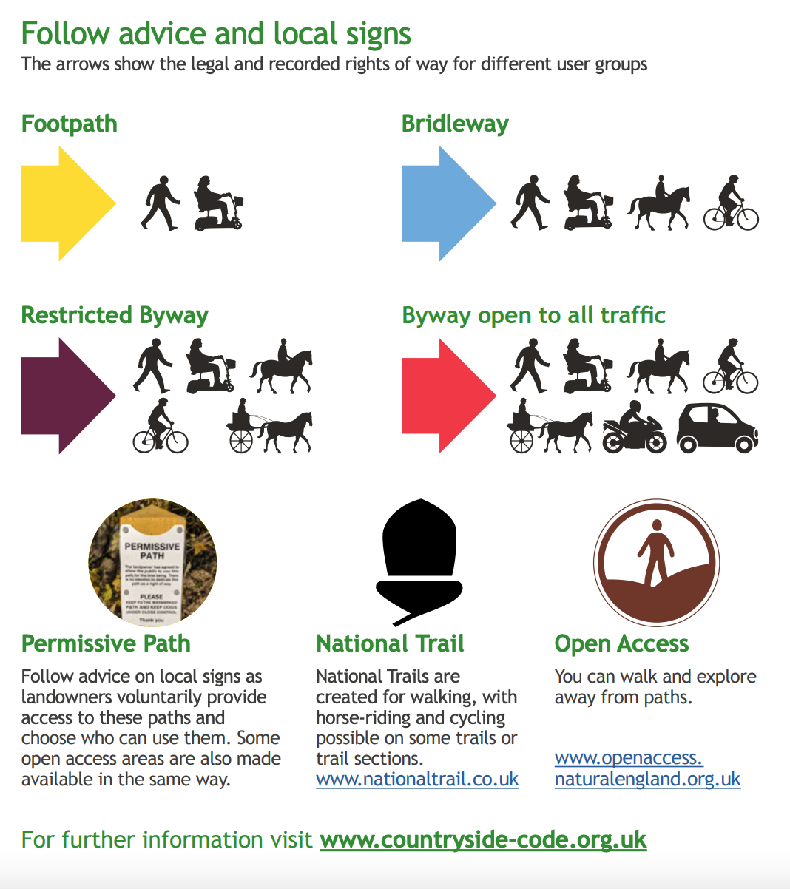

Our Forest School Rules

Rules to repeat at the start of every group of sessions. Children will be asked to remember rules, usually using the ‘rules cookies’ to help.
Our rules are enable us to stay safe whilst having fun.
Additional safety rules will be discussed at the start of each session depending on any potential hazards presented by the activities or environment.
If the children show through their behaviour that they can remember the rules, the repeating of the rules at the start of each session can be adjusted.

No picking (To avoid contact with any toxic plants and to preserve nature).
- Unless an adult tells you to, for example at snack time, or collecting blackberries.

Put nothing near or in your mouth (To avoid consuming any toxic plants or other potentially hazardous materials).
- The only time you can eat or drink is if an adult offers you something at base camp and you have washed your hands

Tree climbing (This is to avoid falls from height or from unsafe branches).
- Don’t climb anything higher than you
- Don’t climb or swing on an any branches thinner than your arm.
- Only climb trees we have told you that you can climb. These will have a flag.
- Only climb if an adult is nearby to watch you. (This rule might change if children respond sensibly).
- One person in a tree at a time and watch out for people below.

Nope rope (Allows us to make safe any hazards in the site, eg. Toxic plants, pond, wood with nails, areas with wildlife).
- Don’t touch anything within a blue rope.

Stay within the Forest School boundary (We need to know where everyone is at all times)
- At school, this is the wildlife area, under the trees to the edge of the playground and the fence alongside the AstroTurf. You can go to the planters, but not on the play equipment. You can go in the shelter, the Forest School shed, the mud kitchen and the pagoda.
- If we are off-site, an adult will explain and mark the boundary.

Sticks and stones
- Definitely no throwing
- Only pick up sticks from the ground, do not pull anything off living trees.
- You can carry sticks the length of your forearm if you carry them by your side with their thumb on top of the stick.
- Long sticks must be dragged by your side with your thumb on top.

Ropes and string
- No ropes or string to be wrapped or tied around yourself or anyone else

Come to the whistle (Important to gather the group in times of emergency or to re-group).
- If you hear the whistle, stop and listen.

No running
- There is lots going on and we can’t always see hazards underneath our feet.

Fire circle
- Walk outside the fire circle and stay seated. Don’t come to the fire square unless asked to by an adult.

The Pond
- The two gates in the nature area will be kept locked as it has the pond in it. The pond has a safety grill on it to stop anyone accidently falling in. Children to be supervised at all times if the grill is taken off.

Most importantly…Have fun
- Communicate with one another, be kind and share. Everything in Forest School belongs to everyone, including the nature.
Our Forest School Code of Conduct

Weather
- As a rule, forest school will go ahead whatever the weather, so participants and adults should be appropriately attired. The forest school leader will organise activities that make the session as enjoyable as possible in varying weather conditions. Forest School will not run if it is too windy (34mph), if there is thunder and lightning, or if the weather has created dangerous conditions eg. ice.

Entering the Forest School Area
- We will walk to the Forest School session location following a Forest School Leader, sometimes behind the trolley.
- On our way, and while we are at Forest School, we will remember that we are sharing the space equally with nature, so we will be careful not damage the environment or the wildlife.

Boundaries and Base Camp
We will gather together at the start at the session, this will normally be on the benches in the nature area or on the round doughnut cushions under the trees in the playground.

- Here we will talk about where the Forest School boundaries are. We must not go beyond these boundaries. It is important that we have places to play out of the sight of adults, but we must be sensible and trusted to do this.
- We know that when our leader blows the whistle we must stop and listen for instructions.
- We must not touch anything surrounded by the ‘nope rope’.
- The toilets are in school so we must go with and adult, like we do at playtime. Ideally we will go before the session.

The Fire and Fire Circle
- The Forest School Leader will always be in charge of fire lighting and the fire.
- Any additional adults involved will be briefed beforehand.
- A lit fire must always be supervised by an adult and never be left unattended
- No fire will be lit until all safety equipment is confirmed and in place
- Fires will only be lit in a designated fire circle. We can sit on the logs/mats that are in a circle 2m away from the fire
- We know that we must not walk around within the fire circle unless we have been invited by the adult in charge of the fire
- If we need to change seats, we must walk around the edge of the fire circle.
- No one should ever go inside the fire square.
- When the fire has been extinguished, it might still be hot so do not touch it (treat it as if it is a fire)
- Cooking on the fire: We will listen to the leader’s instructions to make sure that food is cooked properly and that we let it cool down before we eat it. We will wash our hands before we eat anything, and only eat the foods given to us by the leader.
- The fence gate will be unlocked prior to a fire being lit as an additional escape route.

Using Tools
- All tools have their own set of rules and procedures for use by adults and children which are in our risk assessment. Usually the following rules apply:
- Tools need to be used on a 1:1 basis.
- You must a safety glove on the non-tool hand.
- You must only use tools in the tool area unless you have asked an adult.
- Tools must be returned to the toolbox when not in use
- When cutting with tools, remember to put the object being cut between you and the cutting tool and cut away from you.

Playing with Stones and Sticks
- Only pick up sticks from the ground, do not pull anything off living trees.
- Children can carry sticks the length of their forearm if they carry them by their side with their thumb on top of the stick.
- Long sticks must be dragged by the child’s side with their thumb on top - ‘If it’s bigger than you, it takes two!’
- Children must be aware of others around them (especially behind) when carrying sticks.
- No running with sticks and no throwing.
- Stones can be picked up to use in projects and activities but they must never ever be thrown. Be careful of fingers and toes when you put them down. If you’re moving lots of stones you could wear gloves.

Tree Climbing
- Only trees identified with a flag can be climbed. This means that the tree and the ground below it have been checked by a leader.
- Children are not to climb higher than their own height (max 1.5m) and must not climb on or swing off branches thinner than their arm.
- An adult must be close by to watch.

Gathering wood, natural materials and foraging
- Sometimes we might go on an expedition to the woods to gather materials for our fire and other projects.
- We will be mindful of what we are doing and we will only take what we need to leave nature alone as much as possible. For example, we will gather wood in four thicknesses – matchstick sized, pencil sized, thumb sized and wrist sized.
- We will only pick what our leader tells us to.

Den Building
- Dens must be built safely so that they do not collapse, an adult should supervise to ensure they are structurally safe. If dens are built in a public space they should be dismantled after use in order to adhere to the countryside code and ‘leave no trace’. Dens that remain in situ, eg. in the Forest School site, should be checked as part of the safety sweep.

Digging
- Children may carefully move soil with their hands and small twigs to look for wildlife.
- Deep, big holes should only be made in the digging hole or a digging area shown to you by an adult.

Eating and Drinking
- Children are not to eat or drink anything found in the Forest School area
- Children must never put anything they have found in or near their mouths.
- Children must be reminded not to put their fingers near their mouths, noses and ears.
- We will only ever eat and drink at Base Camp foods and drinks given to us by our leading adults.
- If we have foraged for items such as blackberries, adults will explain carefully how to identify the item and explain why we are allowed to pick it.
- If we are eating and drinking we will wash our hands prior to doing so.

Ropes and string
- We will use rope and string sensibly and put it around ourselves or other children.
- If we want to use rope and string to tie knots and make things we will ask an adults to show us.

Carrying and Transporting Materials
- It is good for children to explore moving materials in different ways; pouring, rolling, dragging etc.
- Adults should model safe lifting by bending their knees and keeping their backs straight.
- Heavy items should be carried safely (eg. Rolled or with two people) and plan where you are going to put it before you lift.

Leaving the Forest School Area
- Everyone should consciously leave no evidence of their time in the Forest School space, unless they are making a positive impact on the biodiversity.
- Manmade materials should be removed eg. String on trees
- Ongoing projects can be left between sessions if they are safe.
- Definitely make sure you take any litter.

The Forest School Shed
- The shed will be kept locked and the code known in the office.
- Some equipment will also be kept locked in the playground shed. Tools, specifically, will be kept in a locked box in a locked shed.
Clothing requirements - ‘there is no bad weather just bad clothes’.

Comfort is paramount to support resilience in all weather conditions. Participants (including adults) should be dressed appropriately as guided by their leader who will take account of the weather forecast and planned activities. It is a good idea for the leader to have supplementary clothing to help participants be able to enjoy and fully participate in the session in case they arrive poorly equipped.

SPRING
- Waterproof trousers and coats
- Covered footwear, usually wellies.
- Quick drying, flexible long-sleeved tops and trousers protect from scratches, stings and sunburn.

SUMMER
- Sunhats (and seek shade) and sun cream (if allowed) on hot days.
- Covered footwear, usually wellies.
- Quick drying clothing will be more comfortable.
- Quick drying, flexible long-sleeved tops and trousers protect from scratches, stings and sunburn

AUTUMN
- Covered footwear, usually wellies.
- Waterproof trousers and coats
- Quick drying, flexible long-sleeved tops and trousers protect from scratches & stings

WINTER
- Warm waterproof coat
- Waterproof trousers
- Additional warm layers (including socks)
- Warm hat
- Covered footwear, usually wellies or sturdier, waterproof thermal boots are much better.
- Warm gloves

Supplementary PPE
- Long sleeves and trousers also would be sensible for specific activities such as nettle or bramble clearance.
- Gardening gloves are required to protect the hands when doing activities such as stacking or gathering logs, weeding, foraging, digging or dry-stone walling.
- Long hair should be tied back for fires.

Forest School Procedures – How a session works

Site Safety Sweep
- Prior to each session a site safety sweep form (see appendix) must be completed by a Level 3 Trained Forest School leader to identify any hazards. Use the nope rope to identify any hazards if necessary.

Participant information – check with the office
- Be aware of the needs of your participants prior to the session.
- Do they have any special requirements – adjust the session accordingly and consider additional adults.
- Do they have any medical needs or allergies?
- Have their parents consented to photographs?

Additional Adults
- There must be a suitable ratio of adults to children, it should be 1:6.
- All adults must have read this document and signed the ‘supporting adults signature sheet’ to ensure they are familiar with procedures to keep everyone safe and understand the Forest School Ethos, ie. what we are trying to achieve.
- The number of adults will depending on the needs of the participants attending and the activities taking place, eg. Off site visits, fire and tools.

Before Forest School starts
- Everyone must try and go to the toilet prior to the session.
- Children should get changed in their classroom/school toilets into their clothes from home. Children in Class Stream will get changed into waterproofs and wellies provided by school. Discuss the weather and our choice of clothing.
- Children should apply any sunscreen from home.

Collection from the classroom and travel to Forest School
- The Forest School leader collects the children from the classroom confirming numbers with class teacher. Headcount the children before leaving the premises. With class stream this is on the stpe by the blue door.

- Walk in a line to Forest School across the crossing to the playground or up the path to the woods.
- We only have to cross a road if we are going to the field. In this case, we will walk in pairs down the path past the church. We will wait at the crossing until an adult tells us it is safe to cross.
- If we are walking into the woods, walk in single file up the thin footpath to where the leader says to stop. If the path is wide enough we will walk in pairs.
- There will always be an adult at the start and end of the line.

Session Plan (1.5 hrs plus changing time)
- Gather at meeting point and sit down.
- Leader to perform a head count.
- Revise the relevant Forest School rules and boundaries, taking it in turns to choose a wooden ‘cookie’.
- Discuss any safety issues that have been identified on the Safety Sweep or session plan.

- Introduce a theme, eg. Spring ‘waking up’ or hibernation, illustrate by reading a story or poem, listen to a song, showing an object such as a nest etc.
- Explain the activities for the session.
- Participants choose activities of their choice, supported by adults. Younger children may require more direction. (give a 5 minute warning before the end of play).
- Tidy up.

- Toward the end of the session, gather for reflection and sometimes a seasonal drink, ie. to warm up in winter or re-hydrate in summer.
- Depending on the activities we might have a snack, eg. Foraged blackberry smoothie, baked apple, popcorn. Wash hands prior to any eating.
- Opportunity here for reflection and discussion about what we have all been doing. Pause for a moment and soak up the nature. What can we see and hear and smell? Talk about the nature of the day.
- Children help with the washing up.

- Play some games eg sit spot.

- Line up on spot in playground or regroup.
- Headcount

- Return to school. Head count.

- Children get changed.
- Wash hands

End of session procedures
- Clear away and store any equipment.
- Count and check off all tools and store safely (locked)
- Collect any paperwork (observation or assessment sheets) from additional adults
- Make notes on session and how to develop for next time. What worked, what didn’t, did the children make any requests? What were they interested in?
- Make sure any dens in public areas are left safe.
- Follow the countryside code and ‘leave no trace’, especially in the woodland.

Health and Safety
We will adhere to the Huntley C of E Primary School Health and Safety Policy.
Additional risk assessments will be done for Forest School activities and settings.

Off Site visits We use the GGC GoVisit risk assessments online system. It is the responsibility of the trip organiser to complete a risk assessment prior to any visit and this will be approved by the Off-site Visits Co-ordinator. The OVC is Mrs E Curtis. The school complies with DfE Guidance and the GCC standards on offsite visits and school journeys.

First Aid
First Aiders
Ruth Credland (Forest School First Aid)
Ella Curtis
Anna Harvey
Alison Goulding

What to do in an emergency
In a medical emergency, using the phone that is part of Forest school essential equipment call 999. If off-site and out of signal range, use walkie talkie to communicate with office.

Communicate with the school office by sending an adult or child (depending on age of participants) and get additional help from school First Aiders.

The school office number is 01452 830510. The office is manned from 8.30-3.15.

When going offsite, take the offsite bag, which includes mobile phone numbers of staff.

Safeguarding Children and Confidentiality

School Safeguarding Officers
Ella Curtis, Alison Goulding, Sheralee Bramley

Huntley C of E Primary School is committed to safeguarding and promoting the welfare of children and expects all staff and volunteers to share this commitment.

Every child has the right to be kept safe from danger and learn in a safe and secure environment, Forest School is no different.
Huntley C of E Primary School Safeguarding Statement
Huntley C of E Primary School is committed to safeguarding and promoting the welfare of children and expects all staff and volunteers to share this commitment.
This means that we have a Safeguarding and Child Protection Policy and clear procedures in place which we refer to in our prospectus. Parents and carers are welcome to read the Policy below or alternatively a printed copy of the policy can be requested.
Sometimes we may need to share information and work in partnership with other agencies when there are concerns about a child’s welfare. We will ensure that our concerns about our pupils are discussed with his/her parents/carers first unless we have reason to believe that such a move would be contrary to the child’s welfare.
Please contact one of our designated leads if you have any queries or concerns. We are always available to talk anything through and signpost to further support if needed.
Please see the school website policies section for these documents. You can also find copies in the school office.
https://www.huntleyprimaryschool.co.uk/school-information/policies

At Forest School, adults will follow the Huntley CE Primary School Child Protection and Safeguarding Policy which is reviewed annually.
DSL: Ella Curtis
DDSL: Sheralee Bramley and Alison Goulding

Confidentiality
At Forest School, adults will follow the Huntley C of E Primary School Confidentiality Policy which is reviewed every 3 years.
All personal information about children is confidential and should only be accessed by staff on a need-to-know basis. Huntley Primary School has a duty of care and responsibility towards children, parents/carers and staff. The care and safety of the individual is always paramount.

Following the guidance in our Safeguarding and Child Protection policy, where information of a sensitive nature is disclosed, this must be treated seriously and with sensitivity. Under no circumstances must a promise be made that you will not tell anyone else.
If a child discloses information that indicates that they may be at risk of abuse, neglect or harm, you must seek further advice as indicated in our Safeguarding and Child Protection policy.
All staff must be aware that they cannot promise a child to keep secrets which might compromise the child’s safety or wellbeing.

All staff and volunteers at Forest School must be aware of the following guidance on confidentiality:
Photographic and Video permissions
- We will take photos at Forest School for use in school and on the school website. We will not publish photos of children whose parents have asked us not to.
- Only school cameras and iPads must be used for this purpose (Mobile phones should only be used for emergency purposes).
Medical and personal information
- All adults will be made aware of any medical details such as allergies affecting the children attending on a need-to-know basis and kept confidentially
- In case of emergency, contact numbers of each child will be kept in the school office
- Only trained staff will apply first aid to children and adults attending; volunteers must make staff aware if they are approached by a child needing care
- Any adults attending, with medical conditions, must disclose to the Forest School Leader; this information will be treated in confidence.
Observations
- Trained staff will be required to undertake observations and assessments of the children attending.
- Observations will be kept in school and remain confidential to that child and family
- Volunteers may give oral feedback to a staff member but this must be in strict confidence.

Legislation

Forest School will adhere to all school policies, as found on the school website.

Accessibility
We will follow the Huntley C of E Primary School Accessibility Policy to make Forest School as inclusive as possible for every pupil.
Extract from policy:
The SEN and Disability Act 2001 extended The Disability Discrimination Act 1995 (DDA) to cover education. Since September 2002, the Governing Body has had three key duties towards disabled pupils, under Part 4 of the DDA:
- Not to treat disabled pupils less favourably for a reason related to their disability;
- To make reasonable adjustments for disabled pupils, so that they are not at a substantial disadvantage;
- To plan to increase access to education for disabled pupils

Behaviour
We will follow the Huntley C of E Primary School Behaviour Policy.
The following extract explains the ethos underpinning the policy.

It is a primary aim of our school that every member of the school community feels valued and respected, and that each person is treated fairly and well. We are a caring community, whose values are built on mutual trust and respect for all. The school behaviour policy is therefore designed to support the way in which all members of the school can live and work together in a supportive way. It aims to promote an environment where everyone feels happy, safe and secure. The school has adopted three core values: Respect, Courage and Perseverance. The first of which underpins all our relationships within the setting. In addition, we have twelve other Values for living. Creativity, Wisdom, Compassion, Truthfulness, Generosity, Responsibility, Friendship, Service, Justice, Peace, Thankfulness and Forgiveness. These values and the British Values, permeate through all school life including through worship, the curriculum and community times. The primary aim of the behaviour policy is a means of promoting good relationships, so that people can work together with the common purpose of helping everyone to learn, rather than a system to enforce rules. This policy supports the school community in aiming to allow everyone to work together in an effective and considerate way. The school expects every member of the school community to behave in a considerate way towards others, whatever their background. social circumstances, ability, ethnicity or culture. We treat all children fairly and apply this behaviour policy in a consistent way. This policy aims to help children to grow in a safe and secure environment, and to become positive, responsible and increasingly independent members of the school community. The school rewards good behaviour, as it believes that this will develop an ethos of kindness and co-operation. This policy is designed to promote good behaviour, rather than merely deter anti-social behaviour.

Safety
The safety of the children is paramount in all situations. If a child’s behaviour endangers the safety of others, the class teacher stops the activity and prevents the child from taking part for the rest of that session. If a child threatens, hurts or bullies another pupil, the class teacher records the incident and the child is sent to the head teacher during playtime. If a child repeatedly acts in a way that disrupts or upsets others, the school will contact the child’s parents and seeks an appointment in order to discuss the situation, with a view to improving the behaviour of the child. All members of staff are aware of the regulations regarding the use of force by teachers, as set out in DfE Circular 10/98, relating to section 550A of the Education Act 1996: The Use of Force to Control or Restrain Pupils. Staff only intervene physically to restrain children or to prevent injury to a child, or if a child is in danger of hurting him/herself. The actions that we take are in line with government guidelines on the restraint of children. (See Physical Intervention Policy)

Bullying
The school does not tolerate bullying of any kind. If we discover that an act of bullying or intimidation has taken place, we act immediately to stop any further occurrences of such behaviour. While it is very difficult to eradicate bullying, we do everything in our power to ensure that all children attend school free from fear. (See Anti-bullying Policy)

Racial harassment
Racial harassment of any kind will not be tolerated. Any such incidents will be reported to the Head Teacher who will record them. Parents of any pupils involved will be invited into school to discuss the matter and to agree a course of action. Repetition of such harassment will result in exclusion.

Sharing behavioural expectations (extends to Forest School)
The class teacher will remind pupils of the school rules for class and playground behaviour. These are agreed annually during an assembly and are revisited by the whole school termly. They can be found displayed on the wall of each classroom. In this way, every child in the school knows the standard of behaviour that we expect in our school. If there are incidents of anti-social behaviour, the class teacher 6 discusses these with the whole class during ‘circle time’. We also have a homeschool agreement. Where unacceptable behaviour (including bullying) does occur over a period, a behaviour book will be discussed with relevant pupils and parents, then sent home to be signed daily until it is deemed unnecessary.

Data Protection
We will take the emergency contact details of adults helping at Forest School. In doing so we will adhere to the Huntley C of E Primary School Data Protection Policy.

Using and Storing Tools

Before embarking on tool work, the leader should understand who they are working with and build up trust. Where is the child developmentally? Start with a small tool such as a potato peeler and do some whittling to get participants used to the feeling of working with a sharp tool and with wood. Demonstrate, gauge their level and scaffold from here, depending on a child’s age, strength, confidence ability to listen and skill level.
Using tools requires a child to earn respect which has positive emotional impact. It is empowering to be able to master the use of a tool to good effect. Children develop fine and gross motor skills by using tools and materials they perhaps might not normally have access to.

Maintenance of rope should adhere to the appropriate legislation, which, in the UK, is PUWER Provision and Use of Work Equipment (1998).

Tool rules that always apply:
- Tool work always takes place in a designated tool area into which participants are invited.
- Tools are only to be used under supervision from qualified Forest School Leader at the correct ratio.
- Put on a tool glove (on the non-tool hand), or gloves. No glove no tool.
- Children are taught how to select the right tool for the job and to be aware of people around them, especially behind.
- All tools are modelled before use: Tools are only ever to be used for a specific purpose
- Children must never be allowed to help themselves to tools and must always have adult supervision when using and collecting tools.

Tool storage
- Tools must be returned to the toolbox when not in use, ensuring that they are clean and dry.
- All tools are counted out and back in at the beginning and end of each session.
- Participants should be taught to tell their leader if they think there is anything wrong with a tool, e.g. It needs sharpening.
- Prior to each session the leader should check that tools are safe to use and in good condition.
- The tools are kept in a locked toolbox then in a locked shed in the playground.
- To ensure that all tools are accounted for, an inventory of tools should be kept in the tool box as well as a tool maintenance log (see appendix)..

NB: This is a guide for tools that I envisage we will use initially. When the time is right, more tools may be introduced at which point this section will be extended with additional risk assessments.
TOOL & USE | RATIO | SPECIFIC TOOL USE GUIDANCE & MITIGATION
HAMMER  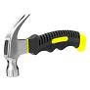 | 1:1 | - Wear goggles  - Concentrate and be aware of other around you  - Stand correctly with your feet apart
DRILL  (Electric or Hnad)   | 1:1 | - Any items being drilled need to be clamped down.  - Wear goggles  - Stand correctly with your feet apart
PRUNING SAW  Cutting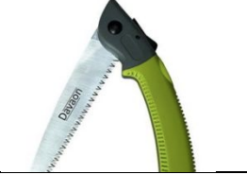 | 1:1 | - Define the location – kneeling pads are good for this or draw with a stick on the floor.  - Make sure that an object (e.g. Toolbox, log, sawhorse) is in between the tool and the body.  - Make sure the wood you are going to cut is secure. Ask a friend to help hold it (with a glove), use clamps or a sawhorse.  - If necessary, kneel closest to the tool with the other leg up. This provides stability.  - An adult must open and close the blade.  - Allow the tool to do the work (don’t add too much pressure)  - Use the full length of the saw  - A kneeling pad makes the task more comfortable, which increases the likelihood of success as well as reducing any damage to the knee from the floor.
PEELER  Whittling  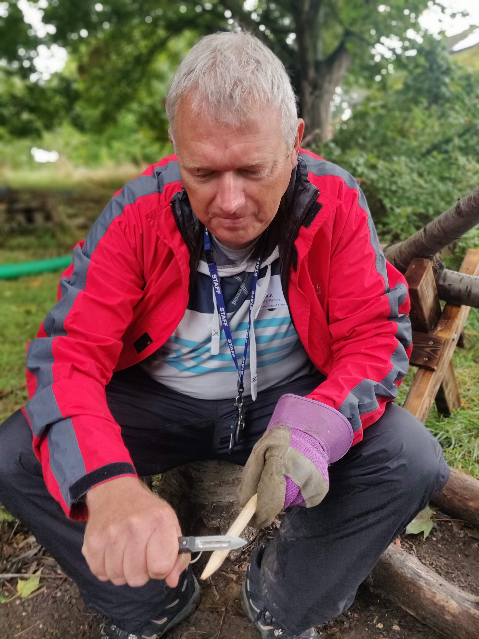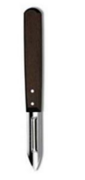 | 2:1 | - Sit down and glue your gloved elbow to your knee.  - Cut away from yourself.  - Make sure that an object (e.g. Toolbox, log, sawhorse) is in between the tool and the body.
SMALL SHARP KNIFE  Whittling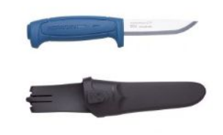 | 1:1 | - Get in position: Sit down, feet shoulder width apart, elbows on knees, whittle away from yourself.  - Gentle pressure using the full length of the blade.  Knife to be kept in sheath (if applicable) at all times when not in use.  - Clean the tool with wet/dry sandpaper.
AXE  Splitting  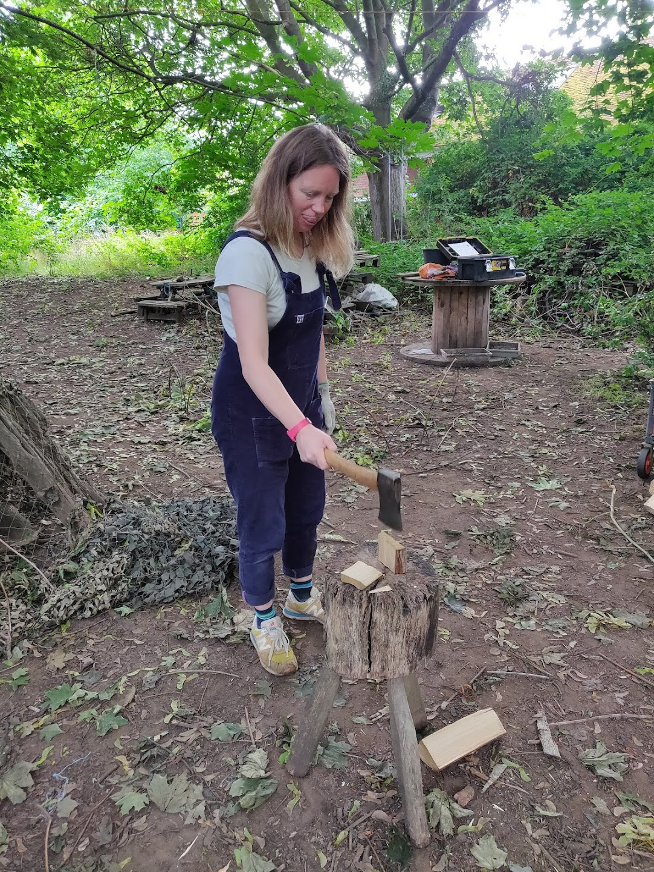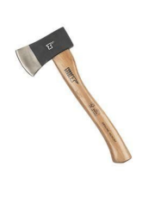 | 1:1 | - Make sure an object is in between your body and the tool.  - Use a cutting block. Make sure it’s on flat ground and is steady.  - The axe should always come straight down. Move the wood if necessary to a 45degree angle if you are using the axe to shave wood off.  - You can use a rubber mallet in combination with an axe.  - Make sure the body is positioned so it avoids the swing of the axe.
SECATEURS  Cutting   | 1:1 | - Allow the tool to do the work – if it’s too hard, it might be the wrong tool.  - Only open the tool ‘mouth’ when hungry – when you’re ready to cut. It should be closed the rest of the time.
Hacksaw  Cutting | 1:1 | - Allow the tool to do the work – if it’s too hard, it might be the wrong tool.  - Make sure the wood you are going to cut is secure. Ask a friend to help hold it (with a glove), use clamps  - Wear goggles  - Wear a tool glove

